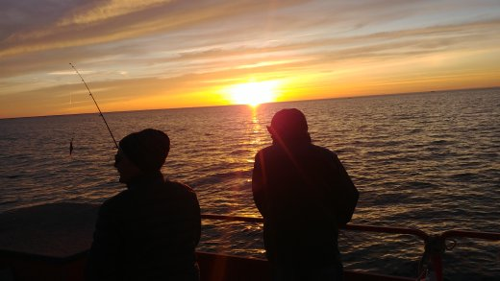
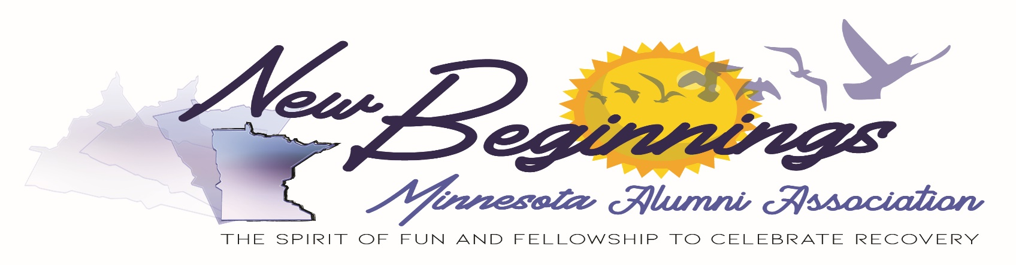

16th Annual
Fishing Bash
McQuoid’s Inn
1325 Hwy. 47 North
Isle, MN 56342
(SE Corner of Mille Lacs Lake)
Lake Mille Lacs

June 17, 2023 @5:30 pm
Launch Departs Promptly @ 6:00 pm

$40 per person

Includes:
4 Hours Guided Fishing Fish, Gear & Bait
Dinner, Soda, Snacks etc.
Contact:
Bob B. 952-567‐9821 becker300.bb@gmail.com

Friends, Fun, Food & Fish

