Recovery Weekend 2018
SEPTEMBER 14TH TO SEPTEMBER 16TH
Mississippi Headwaters Hostel Itasca State Park
27910 Forest Lane Park Rapids, MN 56470
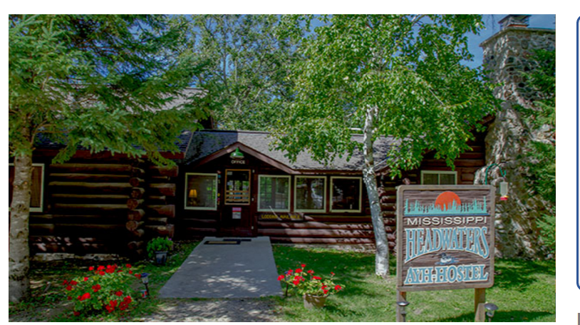

PLEASE COME AND EXPERIENCE A WEEKEND OF RELAXATION AND FELLOWSHIP
Cost for the weekend is $70 per person
Please contact Lisa to register at sandbergmendes1@gmail.com or 651-301-5228

