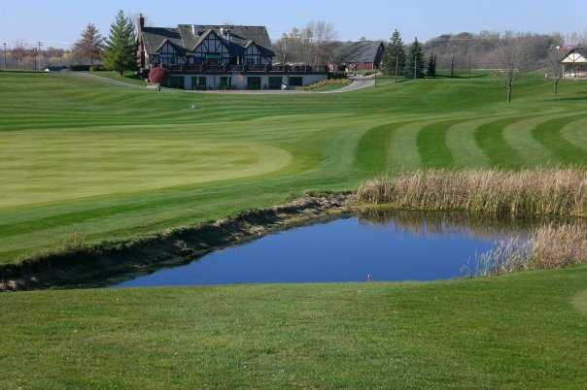

**2018 ANNUAL GOLF SCRAMBLE**

**NBM ALUMNI ASSOCIATION**

**11th ANNUAL GOLF SCRAMBLE**

**Location:** Fox Hollow Golf Club

4780 Palmgren Ln

St Michael, MN 55376

**Date:** August 19th, 2018

**Time:** 1pm – Tee Off

5pm – Dinner/Prizes

**DONATIONS FOR EVENT**

Your donations will fund the Alumni’s many activities which support the long-term recovery of NBM clients! *(Tax deductible)*

**$75 Individual:** 18 holes, cart, goodie bag, dinner, and fellowship

**$400 Package Sponsor:** 4 golfers, 18 holes, cart, goodie bag, dinner, fellowship, ***AND hole sponsorship***

**$500 Golf Cart Sponsor:** Have your company logo on the ~50 carts used for the event!

**$500 Dinner Sponsor:** Have your company logo at every table for the 100+ attendees.

**$500 Driving Range Sponsor:** Have your company logo for the warm up sessions.

**$500 Driving Range Sponsor:** Have your company logo for the warm up sessions.

**SIGN UP TODAY BEFORE THE CARTS FILL UP!**

Contact Jeff Rempel at [rempelhardwood@yahoo.com](mailto:rempelhardwood@yahoo.com) 612-232-1946

Or Mike Weinauer at [mikeweinauer@yahoo.com](mailto:mikeweinauer@yahoo.com) 952-200-9388

**JOIN US TO SUPPORT RECOVERY!**

